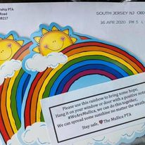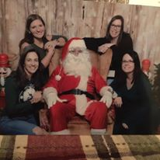

***What’s Missing?* You Are!**

**Let’s Put the “P” Back in PTA!**

Research shows that children perform better when parents are involved. .both at home and at school

1. **Send into school**: Provide your name and email and send along with your $5.00 annual membership in an envelope marked “PTA”.
2. **Mail it to us:** Provide your name and email and mail along with your $5.00 annual membership to:

Mullica Township PTA

PO Box 172

Elwood, NJ 08217

1. **Venmo:** Send your $5.00 annual membership directly via Venmo to @Rebecca-Leek-2. Be sure to provide your name and email in the comments.

Mullica Township PTA

PO Box 172

Elwood, NJ 08217

# **Three easy ways to join our team!**

*Witness Improvement*

By getting involved, you’ll be part of the solution – making positive changes.

We provide support and resources for teachers and students in and out of the classroom.

*Benefit Your Child*

There is no better way to know what’s happening at school.

PTA connects you to other parents and teachers through meetings, events and communication, helping to build a sense of community.

*Make a Difference*

*Tap Into A Network*

*Get Connected*

Mullica PTA

## Reasons to Join the Mullica PTA

Mullica Township PTA

www.mullicapta.weebly.com

mullicapta@gmail.com